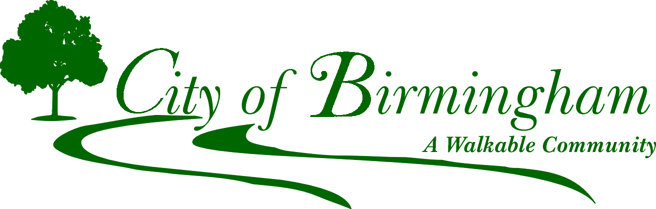

151 Martin St., Birmingham, MI 48009
248-530-1800

1BVIRTUAL MEETING - PUBLIC ARTS BOARD
WEDNESDAY, JULY 21st, 2021
6:30 PM

https://zoom.us/j/93019587189
(Click on Blue Link)
Or dial 1 929 205 6099, MEETING CODE 930 1958 7189

MEETING AGENDA
*** Board members who are not able to attend this meeting are encouraged to notify the staff
representative in advance for consideration of a quorum. ***
- Roll Call
- Approval of Minutes – June 16th, 2021
- Unfinished Business
  - Call for Entry loans
    - Helen Hierta - Meditation Poles
- New Business
  - Call for Entry loans
    - Laurie Tennent – “City Bloom”
    - Michael O’Reilly – Powder Coated Mig Wire
    - Ray Katz – Assorted sculptures (7 total)
- Communication
  - Farmers Market Arts & Crafts
- Public Comments
- Adjournment
Upcoming PAB Meeting: August 25th, 2021

NOTE: Persons with disabilities that may require assistance for effective participation in this public meeting should contact the City Clerk’s Office at the number (248) 530-1880, or (248) 644-5115 (for the hearing impaired) at least one day before the meeting to request help in mobility, visual, hearing, or other assistance.

Las personas con incapacidad que requieren algun tipo de ayuda para la participacion en esta sesion publica deben ponerse en contacto con la oficina del escribano de la ciudad en el numero (248) 530-1800 o al (248) 644-5115 (para las personas con incapacidad auditiva) por lo menos un dia antes de la reunion para solicitar ayuda a la movilidad, visual, auditiva, o de otras asistencias.

